**Bioamp Coding Assignment 1**

I think it is most fun to start by changing things you can see, so let’s start by changing some things about the GUI. These will all be done by changing code in the DAQ.kv file. Here are some simple changes to get you started, I recommend doing them one at a time. For reference, this is what the original GUI looks like, I have showed each change in the questions below.

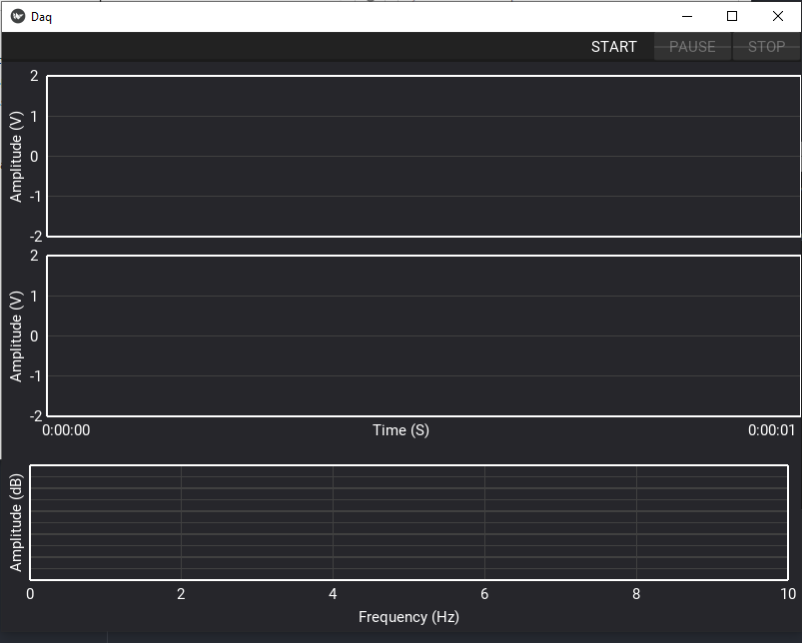

Figure 1. Original GUI with nothing changed

1. **Change the top graph Y bounds from [-2, 2] to [-1, 1]**

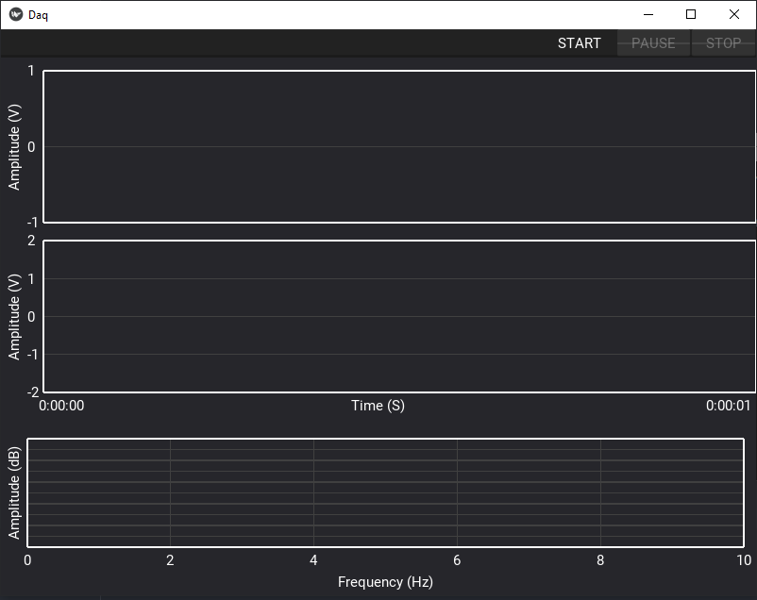

Figure . GUI with Y bounds on top graph changed to [-1, 1]

1. **Change the top graph from grey to blue. Don’t worry about the exact color of blue.**

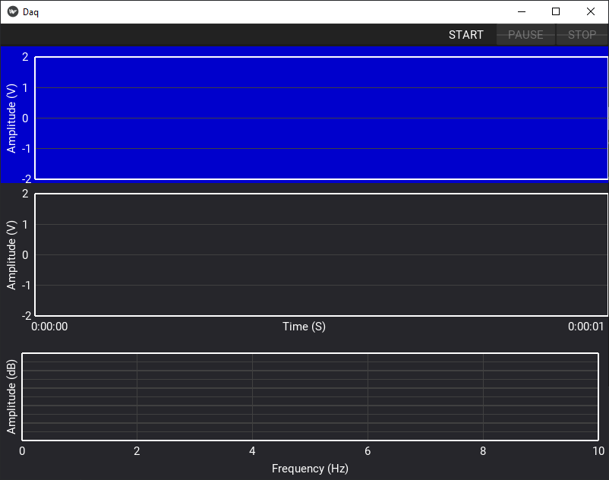

Figure . GUI with top plot changed to blue

1. **Change the start button to say “YOYOYO” instead of “START”**

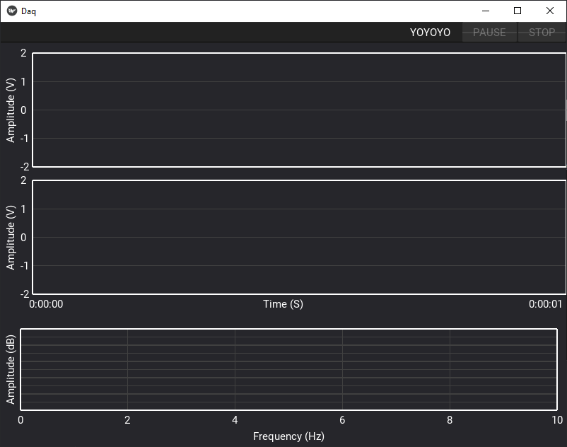

Figure . Start button changed to “YOYOYO”

1. **Add another graph to the GUI**

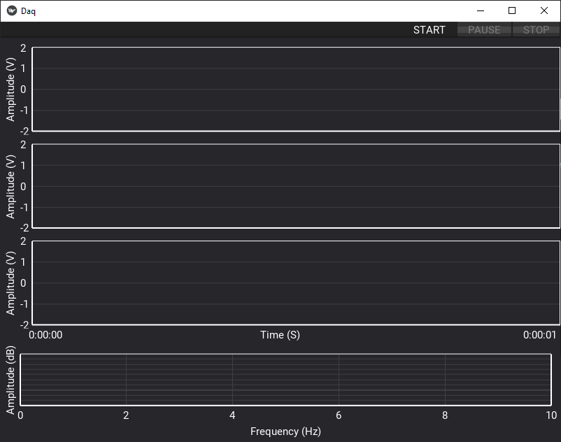

Figure . GUI with extra graph

1. **Add a label to each graph describing the graph, see image for details**

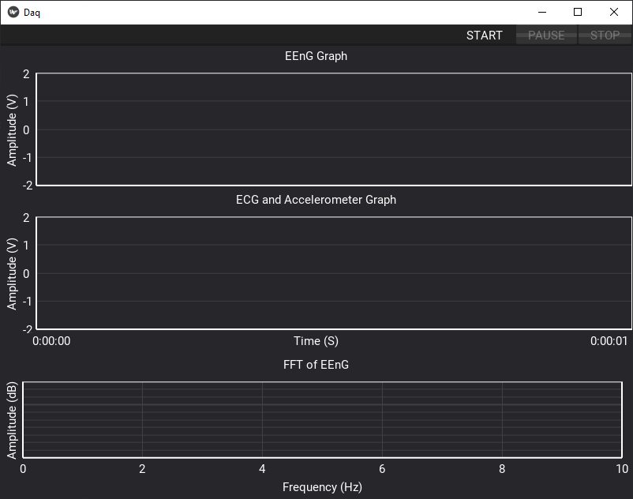

Figure 5. GUI with labels